**Wade Energy Website**

**Landing Page**

Change pictures

ADD TAG LINE: Building science with an energy engineering approach.

**About Us (change “company” to “about us”)**

Wade Energy started in 2011 with a single LED T8 light bulb that revolutionized the lighting world. Over the last 3 years, we have expanded our business into energy consulting, to truly make a difference in costs and energy reduction.

Starting with Title-24 energy code compliance in California in 2012, the company worked hard to offer the best service and fastest turnaround times. As we have been growing, our services and team have as well. We have members currently pursuing LEED accreditation for building design and construction, and existing buildings operation and maintenance. We focus primarily on the energy modelling portion of these projects, but have the skills and expertise to also see a project through as project managers of the entire LEED accreditation process.

In June of 2014 we introduced a third leg to the Wade Energy consulting services, Energy Engineering. This service is focused on studies, analysis and implementation of energy systems. We have members with a background in clean energy engineering, and passive solar design. Within the energy engineering field there are additional analyses that we perform that will help our clients achieve a more sustainable future.

**Team ( change “firm members” to team)**

**Wendy Lee EIT**

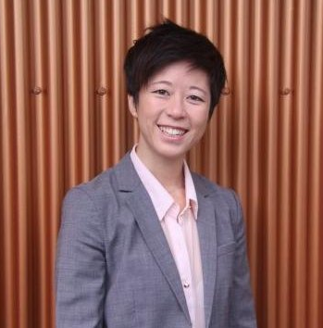University of British Columbia

Masters of Engineering: Clean Energy

Brigham Young University

Bachelor of Science: Mechanical Engineering

Wendy has saved over .5 MW of power through her years as an energy efficiency engineer. She has worked on LEED facilities up to 140,000 square feet and has performed savings calculations on everything from basic lighting to complicated industrial systems. She is currently preparing for the LEED v4 AP BD+C exam. Additionally, she runs her own vacation condo business near Jackson Hole, WY and prides herself on providing excellent customer service. She is currently pursuing her Master’s of Engineering degree to expand her knowledge and expertise.

**Travis Wade**

University of British Columbia

Masters of Engineering: Clean Energy

Sonoma State University

Business Administration: Wine Business

Environmental Studies & Planning: Energy, Management & Design

Travis Wade has a keen understanding of building science, energy modeling, and ASHRAE level II energy auditing. He has worked on a range of LEED projects for University buildings, veterinary hospitals, detention centers, office buildings, and residential homes. He is currently preparing for the LEED v4 AP exam. Aside for LEED energy modeling he has helped test the certified energy analyst exam for the California Association of Building energy consultants on both 2008 and 2013 building energy standards. He is currently completing his Master’s of Engineering degree in Clean Energy to further develop the skills, and knowledge in the energy industry to be more effective in playing a role to mitigate climate change.

**Nick Mott**

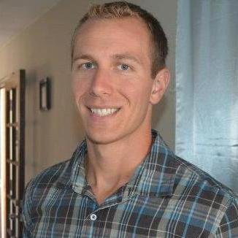Sonoma State University

Environmental Studies & Planning: Energy, Management & Design

Nick has 5 years of Title-24 experience and LEED energy modeling. After completing his studies at Sonoma State he spent 3 years working for EnergySoft, LLC, the company that developed the software EnergyPro. He has worked on LEED energy modeling projects for office buildings, municipality buildings, and education facilities up to 200,000 square feet. Nick also has hands on experience in the field performing HERs measures for the residential market to help home owners qualify for incentives and rebates for home energy upgrades. He is currently preparing for his LEED GA for v4 exam.

**KEEP YOU ON THERE PLEASE!!! AND ADD ANYTHING YOU WANT!!!(this is to randall)**

CHANGE YOUR PICTURE IF POSSIBLE TO SOMETHING MORE CLEAR

**Title-24**

Wade Energy is a CABEC member (California Association of Building Energy Consultants) with CEPE and CEA associates. We have been reviewing the new standards and requirements, and are educating ourselves on the new process that will be required by the CEC (California Energy Commission). Our associates are quick to respond to inquiries and questions from our clients and we are always willing to make revisions and adjustments to meet the needs of your clients. Our services for Title-24 cover all project types in both the residential and nonresidential markets.

* New construction residential projects
* Additions and alterations for residential projects
* New construction non-residential projects
* Lighting, Mechanical, Envelope alterations for nonresidential projects

**LEED Projects + Building Science**

The LEED energy team includes three consultants skilled in energy modeling. They are proficient in EnergyPro and have additional experience with eQUEST and TRACE. With their modeling software expertise and understanding of building systems they will collaborate with the project team to help clients achieve the most points for their LEED building.

In addition to LEED services, we also conduct energy audits and develop reports with a set of energy conservation measures specific to you building.

* LEED Energy Modeling and templates
* LEED AP Building Design + Construction
* LEED AP Existing Building O&M
* ASHRAE Level I & II Energy Audits
* Measurement and Verification
* Mechanical Systems Analysis

Whole Building Simulation for Leadership in Energy and Environmental Design (LEED) Modeling is a requirement of LEED Energy & Atmosphere Credits

LEED Energy and Atmosphere Credit

There are 110 possible credits for a LEED building including all bonus points. Energy and atmosphere credit 1 is the single largest credit, with up to 19 points. Some of the details used in the energy-model can also be used in other credits as well.

Other Benefits of Energy Modeling

* Helps achieve energy efficiency goals
* Provides a path towards additional funding
* Provides an energy consumption baseline and energy patterns

Wade Energy is looking forward to collaborating with you on the next project

**Energy Engineering**

Wade Energy has two associates with a Masters of Engineering in Clean Energy. The professional and practical skills developed in academia have shown to be valuable knowledge in the environmental and sustainability industry. We want to offer this knowledge and understanding to those interested in building for a better future. Our services include:

* Clean Energy Engineering
* Passive Solar Design
* Energy Project Feasibility Studies
* Life-Cycle Analysis

For more details on how these services may be of benefit to you, contact us at [info@wadeenergy.com](mailto:info@wadeenergy.com)

**Contact Us**

Can you make it just like this one: http://www.enerconnect.ca/contact.html

The only difference is that on the left side under the map where it says EnerConnect, Vancouver to do:

Wade Energy

1942 Linda Dr.,

Pleasant Hill, CA 94523

(925) 383-5490

**Appendix**

**Wade Energy is a USGBC member with accredited professional associates. We have been preparing for the new version 4 requirements and are prepared for this next transition. We are focused on being the energy modeling consultant on projects, but also hold the knowledge and skills to conduct project management on the entire LEED process.**